CENTRAL OKLAHOMA ASSOCIATION OF LEGAL ASSISTANTS
2018 ATTORNEY OF THE YEAR NOMINATION FORM
COALA is looking for an individual who has shown outstanding support to the Legal Assistant/Paralegal profession. As a member of the legal community, the nominee understands the value of Paralegals and their contribution to an attorney's practice.
PLEASE E-MAIL OR MAIL COMPLETED FORM TO:
Lynn Havrilla, COALA President
P.O. Box 2146
Oklahoma City, OK 73101
LynnHavrilla@HoldenLitigation.com
PROFESSIONAL AFFILIATIONS

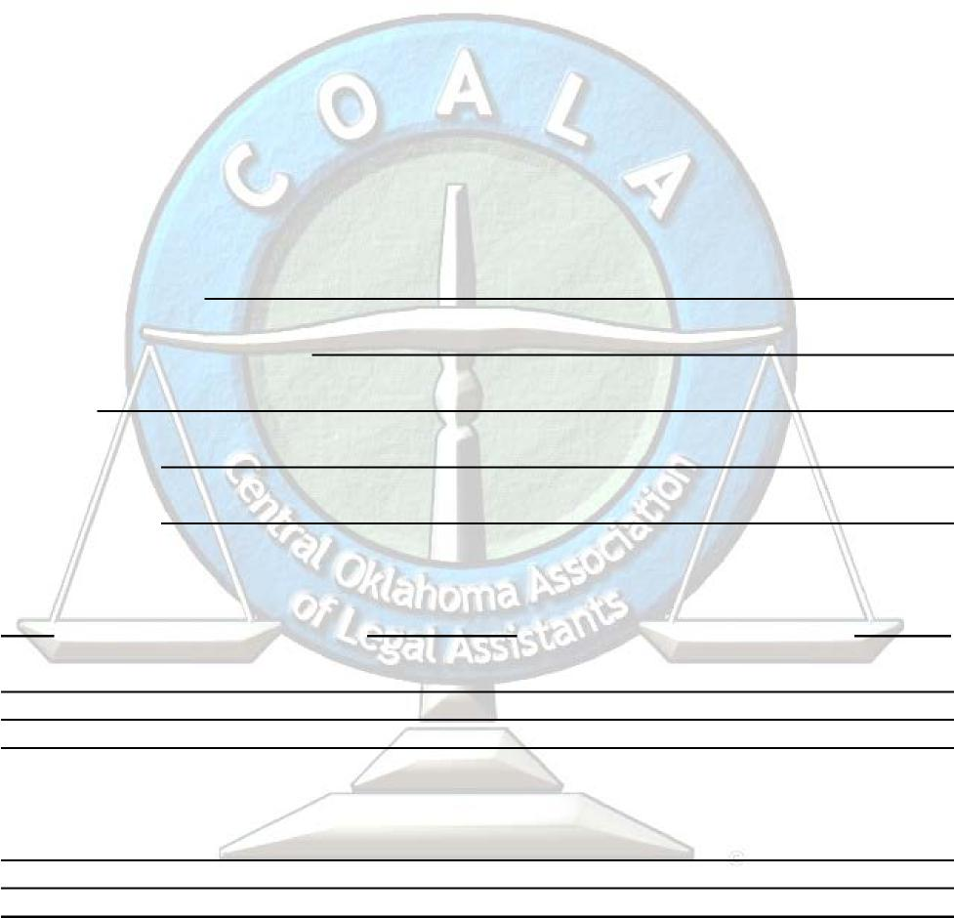
To qualify for consideration, the Nominee must be a practicing attorney, Judge,
educator, or an elected official with a Juris Doctorate Degree.
Please complete the information below to nominate a member of the bar that you feel is deserving of this prestigious award. The award will be presented at COALA'S Annual Attorney/Paralegal Recognition Luncheon on Friday, June 8, 2018, at the Beacon Club, at 11:30 a.m.
DEADLINE FOR NOMINATIONS: FRIDAY, May 25, 2018 at 5:00 p.m.
Name of Nominee:
Nominee's Firm or Business:
Address:
Telephone No: Nominated By:
Year Organization Position
Why do you feel the Nominee is deserving of this award?

